Low Level Design (UPDATE PERSONAL DETAILS module)

Project Code | Team2
Project Name | Online Recruitment Management System

Prepared/Modified by | Role | Date of Preparation
Akash Bansal | Senior Software Analyst | 11/11/2017
Reviewed by | Role | Date of Review
Vaishali Srivastava | Consultant | 16/11/2017
Approved by | Role | Date of Approval
Vishal Mali | Senior Consultant
Circulation List | akash.bansal@capgemini.com,  mvallamk@capgemini.com,  kaustav.saha@capgemini.com,  mohit.deshmukh@capgemini.com | Version Number of the template:1.0
Version Number | 1.3

Table of Contents

1. Description Of The Unit 3
2. References 4
3. Dependencies / Assumptions 5
4. Class Diagrams 6
5. Sequence Diagrams 7
6. Design Components 8
6.1 List Of UI Components 8
6.2 List Of Design Classes 8
7. Re-Usable Routines/Components 9
8. Messages 10
9. Configuration Files 11
10. Crud Matrix Table 12
11. Data Mapping Matrix 13
12. Action Flow Matrix 14
13. Stored Procedures 15
14. Program Specification / Pseudo Code 16
REVISION HISTORY OF THE WORK PRODUCT 17

Description Of The Unit

The update personal details module allows the candidate to update personal details into the database.This functionality is only for candidate.

On clicking the update resume button, candidate is given a list of options. Now, on clicking update personal details link, a form is displayed just below the link. Candidate has to fill the form adhering to the proper validations and then click on the save button in order to save the personal details to the database.
If candidate clicks on save button, the Candidate personal details are inserted into the database and the candidate is again redirected to same page to update other details.
If not inserted, user will be redirected to an error page.

References

Reference | Description
Repository reference | https://IGTEBLRSVNTNG.igatecorp.com/svn/oct3_Team1
Class Diagram | /Project Documents/Design Documents/HLD/Class Diagrams
URS | /Project Documents/Requirements/Case Study/Ecommerce-grp1 and grp3.doc
UTP | /Project Documents/Test Plan/UTP/Test Cases/AddProduct /UTP_AddProductModule.xlsm
DB Design | /Project Documents/Design Documents/HLD/DB Design/E-Commerce_GROUP_DBDESIGN.xls

Dependencies / Assumptions

Dependencies:
The user has already logged in.

Assumptions:
The login details are already present in the database.

Class Diagrams

Class Diagram

Sequence Diagrams

Sequence Diagram
NA

Design Components

List Of UI Components
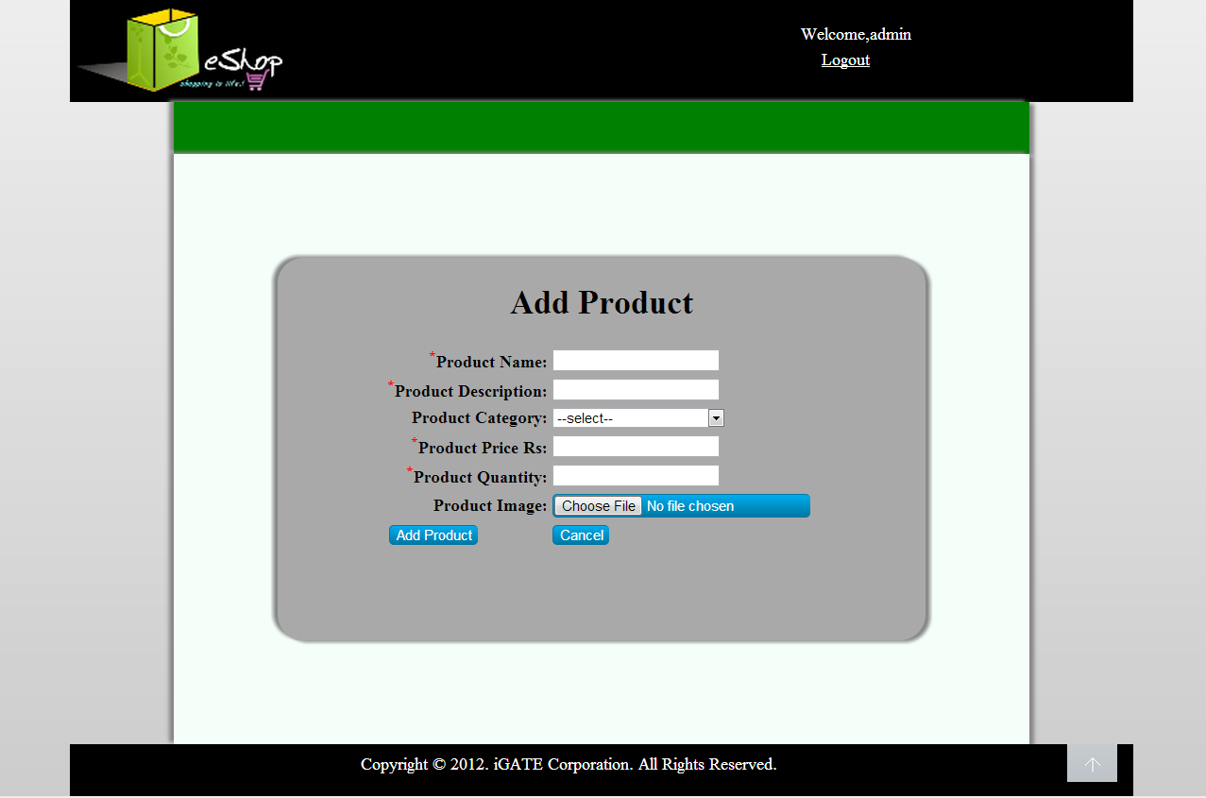

List Of Design Classes
Sr. No. | LLD Name | Class Name | Method Name | Method Description
1 | Add Personal Details  Module | CandidatePersonal | Appropriate getters and setters methods | Getters retrieve the property values and setters set the property values
2 | Add Personal Details  Module | RecruitmentController | modifyPersonalForm(Model model):String  modifyPersonal(@ModelAttribute("candPers") CandidatePersonal candidatePersonal ,Model model):String | Sets the model attribute.  Calls candidPersonal() of RecruitmentServiceImpl class. If no exception occur, it will show home page else it redirects to error page with appropriate error message
3 | Add Personal Details  Module | RecruitmentServiceImpl | candidPersonal(CandidatePersonal) | candidPersonal() of RecruitmentDAOImpl class.
4 | Add Personal Details  Module | RecruitmentDAOImpl | candidPersonal(CandidatePersonal) | Inserts the candidate personal details into the database

Re-Usable Routines/Components

Re-Usable Routines/Components

- CSS files
- Javascript files
- DataAccessException class
- Database xml files
- Logger properties files

Messages

#. | Type | Message Text
M1 | Error | There are no Personal Details. First Add them.

Configuration Files

File Name | Path | Description | File Name | Path | Description
jpaContext.xml | /Development/Source/OnlineRecruitmentSystem/resources | To configure database connection. | oracle.properties | /Development/Source | To configure database connection.
web.xml | /Development/Source/OnlineRecruitmentSystem/WebContent/WEB-INF | To configure the bean properties and request mapping. | Web.xml | /Development/Source | To configure the bean properties.
servlet-config.xml | /Development/Source/OnlineRecruitmentSystem/WebContent/WEB-INF/config | To configure view resolver. | Dispatcher-servlet.xml | /Development/Source | To configure the request mapping and view resolver.
log4j.properties | /Development/Source/OnlineRecruitmentSystem/resources | To configure the logger. | Eshop_logger.properties | /Development/Source | To configure the logger.

Crud Matrix Table

# | Table Name | Create | Read | Update | Delete
1. | CandidatePersonal | N | Y | Y | N

Data Mapping Matrix

Sr. No. | Screen Label | Field Source | Field Type | Data Type | Max Length | Data Flow | Mandatory
1 | Name | NA | Label | NA | NA | UI | NA
2 | txtCandidateName | CandidatePersonal.candidateName | TextBox | Varchar2 | 20 | D->UI  UI→D | Yes
3 | Address | NA | Label | NA | NA | UI | NA
4 | txtAddress | CandidatePersonal.address | TextBox | Varchar2 | 10 | D->UI  UI→D | Yes
5 | Date of Birth | NA | Label | NA | NA | UI | NA
6 | dateDateOfBith | CandidatePersonal.dob | Date | Date | NA | D->UI  UI→D | Yes
7 | Email ID | NA | Label | NA | NA | UI | NA
8 | txtEmailID | CandidatePersonal.emailId | TextBox | Varchar2 | 30 | D->UI  UI→D | Yes
9 | Contact Number | NA | Label | NA | NA | UI | NA
10 | txtContactNumber | CandidatePersonal.contactNumber | TextBox | Number | 10 | D->UI  UI→D | Yes
11 | Marital Status | NA | Label | NA | NA | UI | NA
12 | optMaritalStatus | CandidatePersonal.maritalStatus | RadioButton | Varchar2 | NA | D->UI  UI→D | Yes
13 | Gender | NA | Label | NA | NA | UI | NA
14 | optGender | CandidatePersonal.gender | RadioButton | Varchar2 | NA | D->UI  UI→D | Yes
13 | Passport Number | NA | Label | NA | NA | UI | NA
14 | txtPassportNumber | CandidatePersonal.passportNumber | TextBox | Varchar2 | 8 | D->UI  UI→D | Yes
15 | Cancel | NA | Button | NA | NA | UI | NA

Legend
D → UI (Database to User Interface)
UI → D (User Interface to Database)
UI (User Interface Only)

Action Flow Matrix

Sr. No. | Action | Description | Process
1 | On click of Modify Personal Details link on ModifyResume Page | Opens up the Modify Personal Detail form | The candidate clicks on the modify resume button and a form with personal details will open just below the link
2 | On click of save button on ModifyResume page | The personal details are inserted into the database. | Data is entered in the fields by the candidate which gets updated into the database when save button is pressed.

Stored Procedures

# | Stored Procedure Name  (with Description) | Input/Out Parameters | Type | Size
1. | NA | NA | NA | NA

Program Specification / Pseudo Code

<ACTION :ADD_CLICK >

Pseudo Code:
- Client Side Scripting:
None

- Server Side Scripting:
BEGIN
Call prepareAdd(Model model) in Controller class
Navigate to add page
END

14. 2 <ACTION: ADDPRODUCT_CLICK>

Pseudo Code:

- Client Side Scripting:

IF invalid ProductName
Print Error Message M1
IF ProductName isEmpty
Print Error Message M6
IF invalid ProductDescription
Print Error Message M2
IF ProductDescription isEmpty
Print Error Message M6
IF ProductSubCategory isEmpty
Print Error Message M3

IF invalid ProductPrice
Print Error Message M4
IF ProductPrice isEmpty
Print Error Message M6
IF invalid ProductQuantity
Print Error Message M5
IF ProductQuantity isEmpty
Print Error Message M6
IF ProductImage isEmpty
Print Error Message M6

- Server Side Scripting:
BEGIN
Call processAddPage(@RequestParam("file") String filename,@ModelAttribute("Product") @Valid Product product,BindingResult result,Model model) in Controller class in Presentation Layer
BEGIN
Call addProduct (Product product) in EshopBOImpl class in Service Layer
BEGIN
Call Call addProduct (Product product) in EshopDAOImpl class class in Data Access Layer
BEGIN
Create query for insert records into Product and Product_Image table
Return Integer value.
END
Return Integer value. to Service Layer
END
Return Integer value to Presentation Layer

END
IF successful navigate to home page
Else navigate to add page and show error.
END

14. 2 <ACTION: CANCEL_CLICK>

Pseudo Code:
1. Client Side Scripting:
None

2. Server Side Scripting:
BEGIN
Call prepareHomePage(Model model) in Controller class
Navigate to home page
END

REVISION HISTORY OF THE WORK PRODUCT

# | Date | Version # | Section Changed | Details of changes made | Approved By
1 | 16/12/2013 | 1.0 | LLD prepared | N/A | Uma M Ponniamman
2 | 17/12/2013 | 1.1 | Reusable components,  Pseudo code | Reusable components added.  The pseudo code is modified as per the specified flow. | Uma M Ponniamman
3 | 18/12/2013 | 1.2 | Reusable components,  References,  Data Mapping Matrix. | Reusable Components added.  File name with relative path is added in the references section.  The name of text boxes(screen label is changed). | Uma M Ponniamman
4 | 24/12/2013 | 1.3 | Configuration files,UI Components | Paths of the configuration files is updated and UI components(Screen Shots) added. | Uma M Ponniamman

